A Review of The Music Student’s Practice Journal: Tracking Your Artistry for Success, by Olivia Ellis and Davis Dorrough
By BJ Nicoletti

Also included are links to articles and video about practicing journaling!
Overall, for me, this journal approach is familiar, comfortable and effective with the exception of the practice log not having space for tracking a specific goal, reflection on a specific goal and next steps for that goal. So, my favorite approach remains using a simple notebook using a similar overall approach to this publication. But, for most, particularly with middle/high school and early collegiate players (maybe elementary players too), this approach certainly does much to add structure to students’ weekly goal setting, practice tracking and systematic and routine reflection.
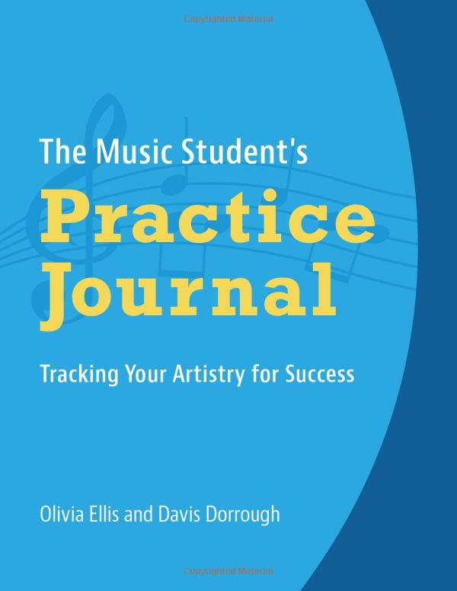
While there are many types of practice journals available, this one may be of particular interest due to it’s simple, but logical and meaningful set-up and content. It was created by the authors after much testing and use in their own music studio. (see pic on next page)
- It has a well balanced focus on long and short term goals, practice strategy and outcomes, and learner reflection. In other words, it isn’t just about tracking “time spent.”
- In the true spirit of a journal, t is designed with plenty of room to write.
- While structured, it doesn’t lock the journalist too narrowly in because the open-ended questions leave room for in individual’s approach to narrating their practice, learning, and needs. See picture on next page (from the Amazon site).
More about the book can be found at this Amazon webpage, simply scroll down for the details including pictures of the page journals and their rationale for designing the book the way they did – click here for more information.

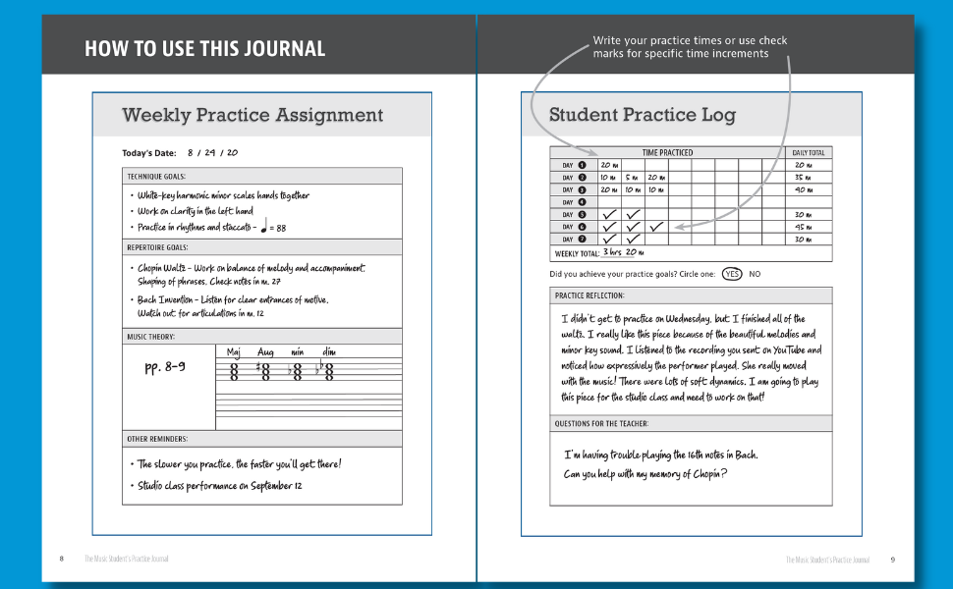

Also on the topic of journaling, here are a few links that may provide additional insight and inspiration.
Articles
- The Ultimate Guide to Starting a Music Journal
- Music Journaling Article from the OnlineMetronome
- The Musicians Practice Journal and Why You Need One, by the Music Industry HOW TO website
- A very different approach, but sensible in several ways. This article also presents the idea of organizing by piece or type of work, including how to use the Evernote as a practice journal tool – A Practice Journal System that Actually Works.

Video
- How to use the Evernote App to help with practice, by FiddleHed (12:37) – integrating audio and text into your journal, and adding links to documents and recordings. You can write or type and easily include pictures.
GPFS 2022-2023 Program Sponsors
The Greater Portland Flute Society thanks our Sponsors for their extraordinary support! Please show your appreciation by giving them your patronage.
Brannen Brothers Flutemakers, Inc.  58 Dragon Court  Woburn, MA 01801-1014  781-935-9522, brannen@brannenflutes.com | Canter Flute Repair  Flute Repair Specialists  Beaverton, OR  Straubinger & Muramatsu Certified  JS Engineering Gold Pads  971-266-4096
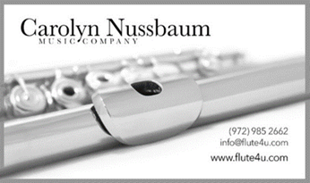  Carolyn Nussbaum Music Company  625 Digital Drive, Ste 300  Plano, TX 75075  972-985-2662, 877-FLUTE4U (toll free)  info@flute4u.com  Watch video | Flute Center of New York  307 7th Ave. #401  New York, NY 10001  212-307-9737, info@flutecenter.com  Watch video
FLUTEWORKS Seattle LLC  Facebook Page  781-526-3677, fluteworks@gmail.com  By appointment only  Watch video | Keefe Piccolo Company  http://www.keefepiccolo.com/  54 Church Street  Winchester, MA 01890  781-369-1626  jim@keefepiccolo.com

Ted Brown Music
6228 Tacoma Mall Blvd
Tacoma, WA 98409
800-562-8938
253-272-3211
sales@tedbrownmusic.com

GPFS 2022-2023 Commercial Members
The Greater Portland Flute Society also thanks our Commercial Members for their support! Please show your appreciation by giving them your patronage.
Burkart  2 Shaker Road, #D107  Shirley, MA 01464  978-425-4500  burkart.com/contact | Miyazawa Flutes  Miyazawa - USA  1214 5th Street, Coralville, IA 52241  1-800-967-6733  info@miyazawa.com
Professional Woodwind Repair  Straubinger Certified  Flute & Double Reed Specialist  119 Neabeack Hill Dr, Philomath, OR 97370  Contact: Katie Cooper, 541-760-8865 katie@windsmithmusic.com  By appointment only. | Sherry Lee Dealer of Fine Flutes  678 Sperber Lane  Grand Junction, CO 81506  970-242-9364  sherrysflutes@gmail.com
Flute World  29920 Orchard Lake Rd.  Farmington Hills, MI 48334  248-855-0410, flutes@fluteworld.com | GPFS is also a proud and grateful recipient of an Oregon Arts Commission grant – 2022.

